Plasma Lighter

1.External Features of Plasma Lighter
- Power Button / Switch
  - Turns the lighter on and off
  - Usually a small push or slide button
- Electrodes / Arc Points
  - Two small metal tips where the electric arc (plasma) appears
  - Positioned at the top of the lighter
- Body / Casing
  - Plastic or metal outer shell
Provides grip and insulation from electricity
- USB Charging Port
  - Allows recharging the lighter
  - Usually micro-USB, USB-C, or Type-A
- Indicator Light / LED
  - Shows battery level or charging status
- Flexible / Long Neck (Optional)
  - Some lighters have extendable necks
  - Helps to ignite hard-to-reach places safely
- Protective Cap (Optional)
  - Covers the electrodes to prevent accidental sparks

2 Physical Construction of a Plasma Lighter
- Outer Body / Casing
  - Made of plastic or metal
  - Provides insulation, grip, and protection to internal components
- Power Switch / Button
  - Activates the lighter
  - Controls flow of electricity to the electrodes
- Electrodes / Arc Points
  - Two small metal tips at the top
  - Produce the plasma arc when electricity passes through
- Battery
  - Rechargeable lithium-ion battery inside the body
  - Provides power for the electric arc
- USB Charging Port
  - Allows the battery to be recharged
  - Usually micro-USB or USB-C
- Indicator Light / LED
  - Shows battery level or charging status
- Flexible / Long Neck (Optional)
  - Some models have extendable or bendable necks
  - Helps to reach deep or awkward places safely
- Protective Cover (Optional)
  - Covers electrodes to prevent accidental sparks

3 Components of a Plasma Lighter
- Electrodes / Arc Tips
  - Two metal tips where the electric arc (plasma) is generated
  - Positioned at the top of the lighter
- Rechargeable Battery
  - Usually lithium-ion
  - Provides the electrical energy to create the plasma
- Power Button / Switch
  - Activates the lighter
  - Controls the flow of current to the electrodes
- USB Charging Port
  - For recharging the battery
  - Can be micro-USB, USB-C, or Type-A
- Indicator Light / LED
  - Shows charging status and battery level
- Casing / Outer Body
  - Made of plastic or metal
  - Protects the internal components and provides insulation
- Flexible / Long Neck (Optional)
  - Helps reach deep or awkward areas safely
- Protective Cover (Optional)
  - Prevents accidental sparks and protects electrodes

4 Operation Modes in Plasma Lighter
- Single Arc Mode
  - Produces one plasma arc between two electrodes
  - Used for lighting small objects like candles, incense sticks, or cigarettes
- Dual / Multiple Arc Mode
  - Produces two or more arcs simultaneously
  - Provides higher heat for lighting BBQ grills, gas stoves, or outdoor fires
- Continuous / Press-and-Hold Mode
  - Arc stays active as long as the button is pressed
  - Useful for igniting larger objects or maintaining flame
- Safety / Auto-Off ModeRecharge / Standby Mode
  - While plugged in for USB charging, lighter cannot operate
  - Ensures safe charging

5 Purpose of Plasma Lighter
- Safe Ignition
  - Provides flameless and windproof ignition
  - Reduces risk of burn injuries compared to matchsticks or gas lighters
- Household Use
  - Lighting candles, incense sticks, and gas stoves
- Outdoor Activities
  - Useful for BBQ grills, camping, trekking, and emergencies
  - Works even in windy or rainy conditions
- Eco-Friendly Alternative
  - USB rechargeable — no need for butane or disposable lighters
  - Reduces waste from matchsticks and fuel-based lighters
- Convenience
  - Portable, reusable, and easy to carry
  - Quick ignition with just one button press
- Emergency Use
  - Reliable source of fire during power cuts or outdoor survival situations
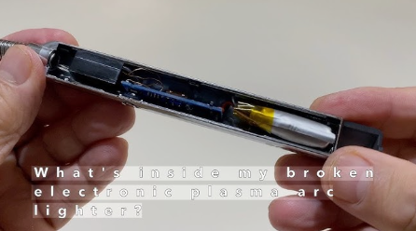

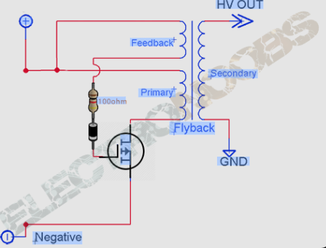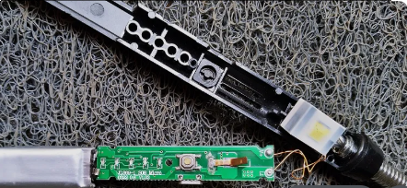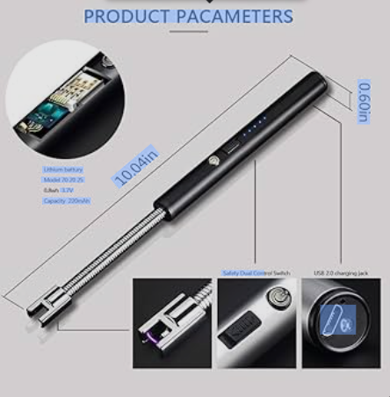

Feature | Plasma Lighter | Traditional Flame Lighter
Fuel | Rechargeable battery | Butane/fluid
Flame | No flame (plasma arc) | Visible flame
Wind Resistance | High | Low
Safety | Often safer (no open flame) | Risky in windy conditions
Upfront cost | Higher | Lower initially
Longevity | Long with care | Depends on fuel & flint
(Based on product info and lighter tech overview)

